**Student’s Project**

**MOROCCO**

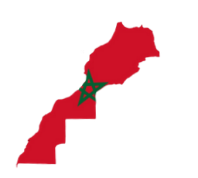

**Quality of Education in Morocco: Between theory and practice**

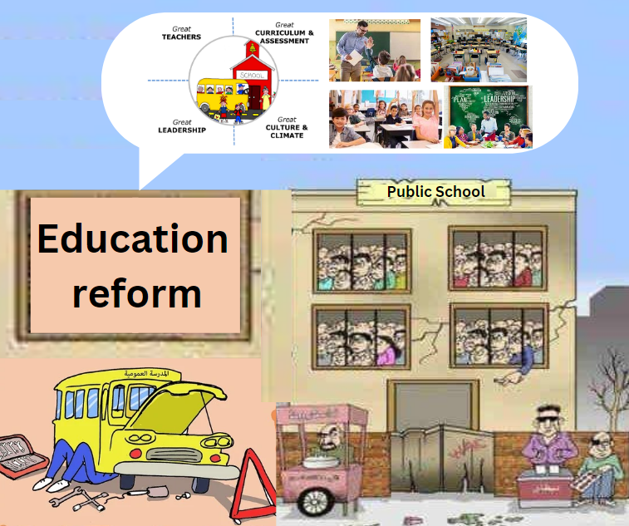

**The researcher : Fatima Zahra Ben Daouia**

Supervised by : Prof. Mohamed Fettah

School: Moulay Ismail High School

**Outline**

1. **Part One (Theory) ...........................................................**
2. **Introduction.**
3. Definitions and indicators of quality education (UNESCO and national benchmarks).
4. Key theoretical principles underlying Morocco’s education system.
5. **Problems and challenges.**
6. The disparity between theoretical education policies and their practical outcomes.
7. The school problems as obstacles to achieving quality education in Morocco.
8. Comparative insights from other developing countries.
9. **Bridging the gap.**
10. Recommendations for aligning national policies with classroom realities.
11. The role of parents and local authorities in achieving quality education in Morocco.
12. **Part Two (Practice) ........................................................**

* **Making a video to highlight the gap between theory and practice and so call to actions for educational reforms that prioritize these practical and inclusive solutions in this research.**



**Abstract**

**This research explores the state of quality education in Morocco. It focuses on the persistent gap between theoretical frameworks and their practical implementation. While the country has made significant strides in reforming its education system, achieving quality education remains a big challenge, especially in bridging the disparity between policy objectives and classroom realities.**

**The research examines the theoretical guidelines of Morocco's education policies including Vision 2015–2030 and the National Charter for Education and highlight their inclusivity, equity, and accessibility in the Moroccan school. Meantime, the research introduces some practical challenges which hinder the realization of quality education.**

**This research also emphasizes the importance of aligning policies with ground realities by adopting a complete vision. Moreover, recommendations are included to improve teacher training programs, increasing investment in school infrastructure, and fostering community involvement to support educational initiatives. Also, lessons from global experiences in similar contexts provide additional insights into effective strategies for achieving quality education.**

**In a nutshell, this research underscores the urgent need to bridge the gap between theory and practice in Morocco's education system. By addressing systemic barriers and fostering collaborative efforts, the country can move closer to realizing its vision of quality education for all.**

"Education is the foundation of civilization and the beacon that guides nations toward prosperity."

Ibn Khaldun